**Embedded Hardware and Operating Systems**

**Week 4 Assignment 1 Report**

Ömer Emre Ekici

**Task 1**

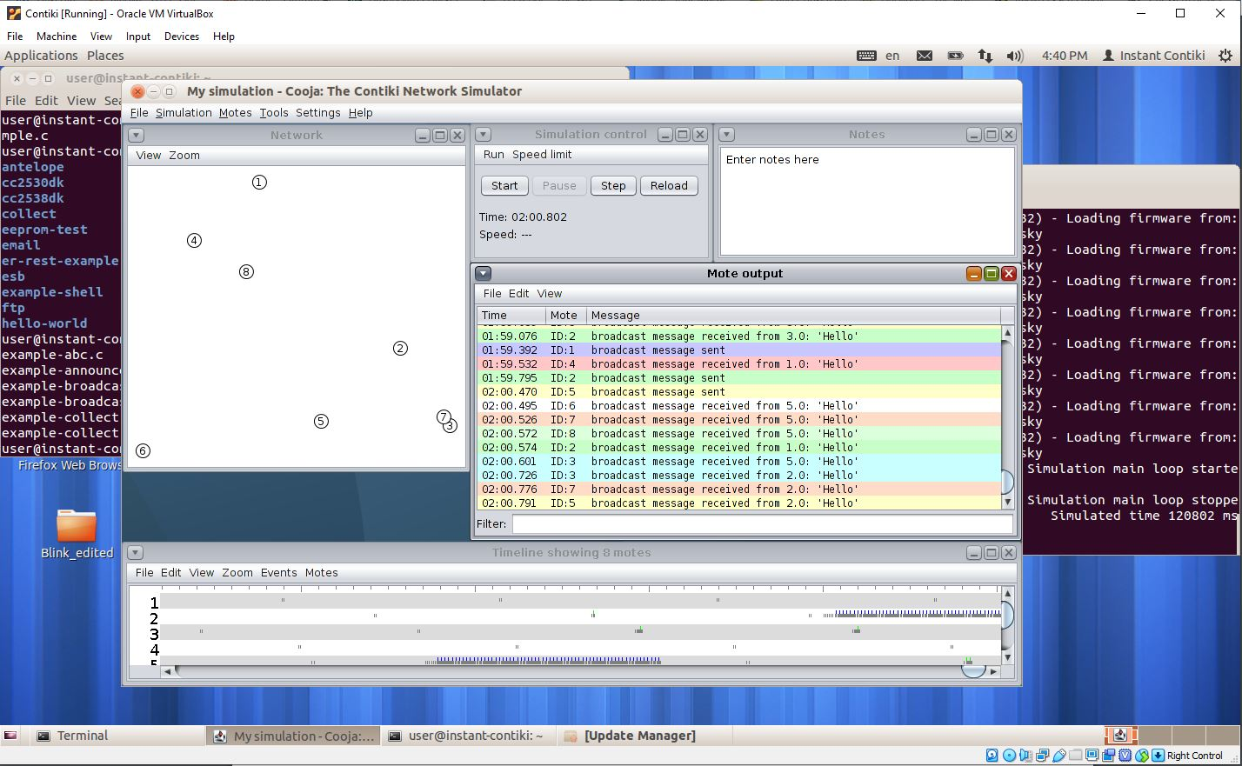

In this part I created 8 broadcast motes with the source code from example-broadcast.c (I was not sure if I should use this file or example-abc.c) . In this setup each mote periodically sends a message packet to other nodes and receives to packets sent from other motes. A line is printed by the mote when it sends or receives a packet.

**Task 2**

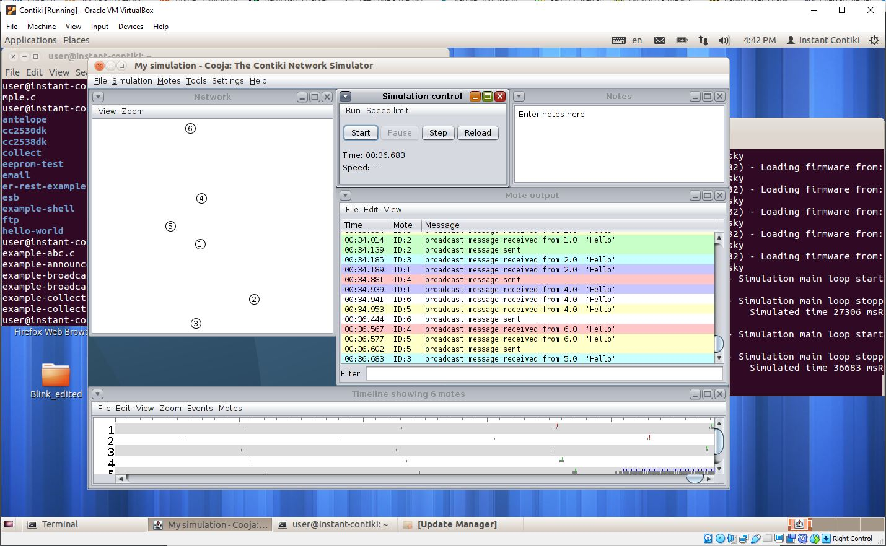

This part is the same as before except there are 6 motes instead of 8. There is less traffic overall when we use 6 motes instead of 8.

**Task 3**

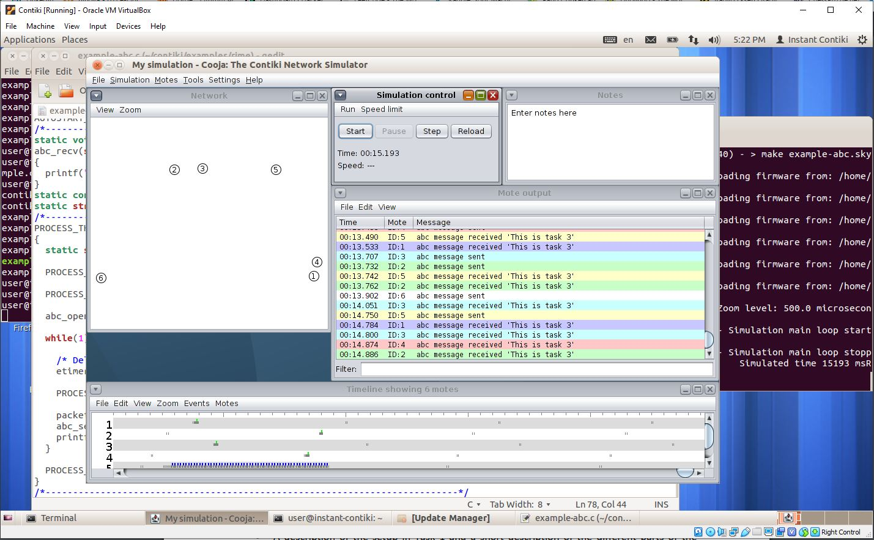

This time I created 6 motes with the examples-abc.c file. The abc layer of the rime stack is the anonymous broadcast layer. This is different from the broadcast layer which adds the sender address to the packet before passing it down to the abs layer.

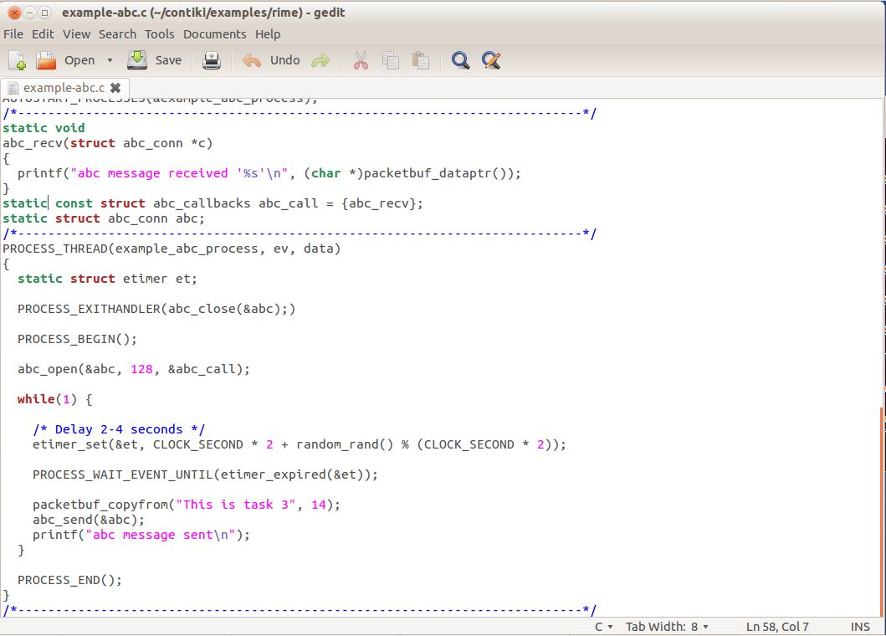

I changed the message of the sender process in the example-abc.c file from “Hello” to “This is task 3”. I also changed the number of characters to be copied to the packet buffer from 6 to 14.